Reducing Conflict With Cougars in the Valley
By: Blakeley Adkins

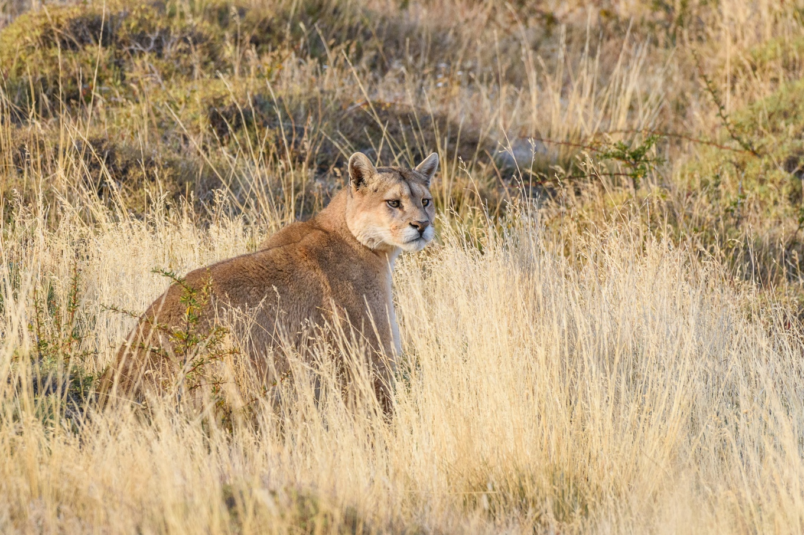

Photo credit: Yuri Choufour

Nestled between dramatic mountain ranges, vast wilderness, and world class waterways, the Wood River Valley is one of the most picturesque locations imaginable. Those of us who live in this awe-inspiring place should remind ourselves daily how lucky we are.

Also, let’s not forget that with this impressive landscape comes the remarkable wildlife that call this valley home. Black bears, wolves and the elusive cougar all reside here. Often and naturally, our first reaction to large carnivores is fearful, however taking the time to better understand them will allow us to be less afraid, decrease conflict, and learn how to appreciate these unique and important species.

Cougars typically sleep during the day, actively hunt from dusk until dawn, and prefer to avoid humans and urban areas. Because of this, sightings are rare. With the increased popularity of remote and security cameras, and surge in social media use, we are more aware of their presence.
Although some wildlife encounters are difficult to avoid, there are non-lethal preventative tools available to mitigate conflict. Relocation or removal of an individual is often a temporary fix while managing attractants has proven to be a more permanent fix.

A cougar’s diet is variable, but mule deer are their prey of choice. There is a large resident deer and elk population in town which increases during the winter. People love feeding these animals, but there are implications to this including spreading disease, habituation, and attracting predators like cougars. Cougars also prey on beaver, rabbits, birds and rodents. If you have bird feeders, water sources, fallen fruit, wood piles or pet food outside you are attracting these species which could in turn be attracting cougars.

Improper garbage disposal is known to increase bear/ human conflicts, but it also attracts small mammals which cougars prey on. It is important to take responsibility for dealing with your garbage appropriately by not leaving it out overnight and using secure containers.

Many valley residents maintain hobby farms. Livestock and poultry could be enticing for cougars, but they are easily deterred by electric fencing and keeping possible snacks in protected enclosures.

Your cat or dog is also a possible attractant. By keeping your pets indoors at night, walking them on a leash, and using motion-activated lighting and tall fences (at least 10 feet) in your backyard you can discourage conflict.

Confrontations with cougars are incredibly rare, but more common with small children. If you are worried about this it is a good idea to remove tall shrubs (which predators use for cover) from areas where kids might be playing, close off openings under crawl spaces and porches where wildlife could hide, encourage kids to play in groups, and supervise them (especially when alone). With that said the Mountain Lion Foundation states your odds of getting fatally attacked by a cougar is one in a billion!

If you do encounter a cougar it’s important to stay calm and do not run, make yourself look big, hold your ground and keep eye contact, speak in a calm voice, and have children close to you if present. Make sure it has an escape route, do not approach it, and back away slowly. If the cougar is acting aggressively throw sticks or rocks at it, speak more firmly and loudly, and use bear spray (if available and you are within 15-25 feet).

There are many ways to live confidently in cougar country. Always report sightings to your local Fish and Game office at (208) 324-4359. Educate yourself on basic ecology and behavior of local wildlife and what to do if you have an encounter. Be aware of attractants on your property and manage them appropriately. Educate children, neighbors and friends. And, be aware that posting sightings on social media could heighten community fear. For more information about discouraging large carnivores from taking up residence in urban areas you can visit the Defenders of Wildlife and People and Carnivores websites and contact your regional Forest Service or Fish and Game wildlife biologists.

